PRACTICE PAPER 1
MATHEMATICS Class – IX

Time allowed : 3hours Maximum Marks : 90

General Instructions :
(i) All questions are compulsory.
(ii) The question paper consists of 31 questions divided into five sections A, B, C ,D and E. Section-A comprises of 4 questions of 1 mark each, Section-B comprises of 6 questions of 2 marks each, Section-C comprises of 8 questions of 3 marks each and Section-D comprises of 10 questions of 4 marks each. Section-E comprises of two questions of 3 marks each and 1 question of 4 marks.
(iii) There is no overall choice.
(iv) Use of calculator is not permitted.

 |  | SECTION-A
 |  | Question numbers 1 to 4 carry one mark each.
 | 1 | y = 0 is the equation of which axis ? |  |  |  |  |  |  | 1
 | 2 | If. and y = 1 then find x. |  |  |  |  |  |  | 1
 | 3 | 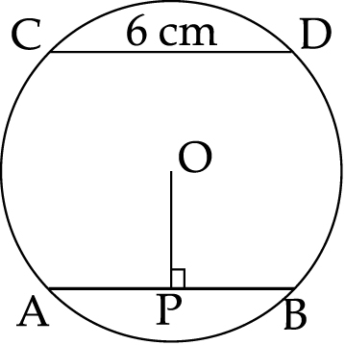  In the figure, AB and CD are two chords equidistant from the centre O. OP is the perpendicular drawn from centre O to AB. If CD6 cm. find PB |  |  |  |  |  |  | 1
 | 4 | If the total surface area of a cube is 96 cm2, then find its volume. |  |  |  |  |  |  | 1
 |  | SECTION-B
 |  | Question numbers 5 to 10 carry two marks each.
 | 5 | PQRS is a parallelogram and X and Y trisect side QR. Show that ar (ΔPQX) is equal to ar (ΔSRY).  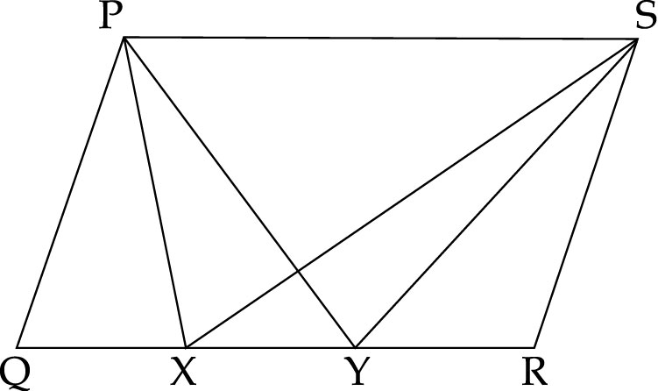 |  |  |  |  |  |  | 2
 | 6 | In the figure, if O is the centre of the circle, ∠ABO50 and ∠ACO20, find the measure of ∠BOC.  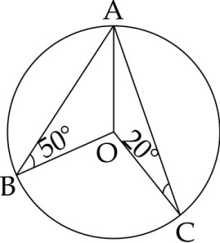 |  |  |  |  |  |  | 2
 | 7 | In a quadrilateral ABCD, ∠B45, ∠D3∠B, and ∠C2∠B. Find the value of ∠A. |  |  |  |  |  |  | 2
 | 8 | The outer and the inner radii of a hollow sphere are 12 cm and 10 cm. Find its volume. |  |  |  |  |  |  | 2
 | 9 | In a football match, a goalkeeper of a team can stop a goal 32 times out of 40 shots by a team. Find the probability that a team can make a goal. |  |  |  |  |  |  | 2
 | 10 | Out of 35 students participating in a dance competition 10 are boys. What is the probability that the winner is a girl ? |  |  |  |  |  |  | 2
 |  | SECTION-C
 |  | Question numbers 11 to 18 carry three marks each.
 | 11 | Identify the points whose co-ordinates are given in the following table which lie on the graph of 2xy0  x 1 0 1 4 3  y 2 0 2 2 6  Draw the graph of the equation. |  |  |  |  |  |  | 3
 | 12 | The cost of 2 tables exceeds the cost of 3 chairs by ` 120. Form a linear equation in two variables to represent the situation. Also find the cost of one table, if the cost of the one chair is ` 60. |  |  |  |  |  |  | 3
 | 13 | In ΔDEF, P is mid – point of EF and Q is mid – point of DP. If ar (ΔDQF)6cm2, find ar (ΔEQF).  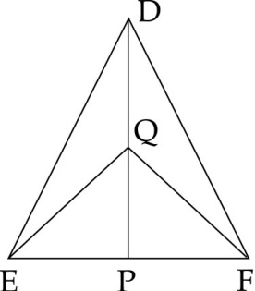 |  |  |  |  |  |  | 3
 | 14 | If two equal chords of a circle intersect within a circle, prove that the line segment joining the point of intersection to the centre makes equal angles with the chords. |  |  |  |  |  |  | 3
 | 15 | Draw a line segment AB10.4 cm. Find AB, using ruler and compass. |  |  |  |  |  |  | 3
 | 16 | In a parallelogram PQRS show in the figure below, the bisector of ∠Q also bisects side SR at X. Prove that PQ2PS.  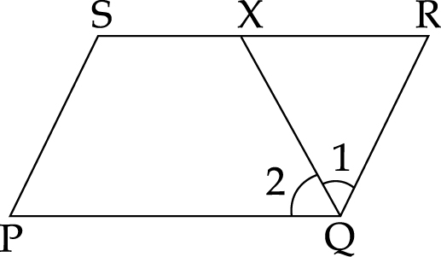 |  |  |  |  |  |  | 3
 | 17 | Construct a rhombus whose each side measures 5 cm and one of its angles is of 60. |  |  |  |  |  |  | 3
 | 18 | The curved surface area of a cone is 12320 sq cm. if the radius of its base is 56 cm, find its height. |  |  |  |  |  |  | 3
 |  | SECTION-D
 |  | Question numbers 19 to 28 carry four marks each.
 | 19 | Let x and y be two supplementary angles. Form an equation for this information and draw its graph. Find graphically measure of the other angle, if one of the angles is :  (a) 120 (b) 80 |  |  |  |  |  |  | 4
 | 20 | Write the equation of the lines drawn in following graph. Also, find the area enclosed between them.  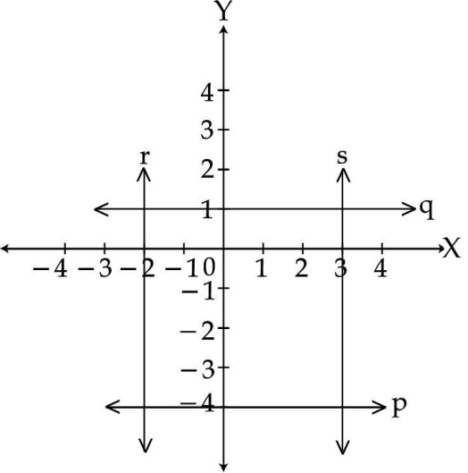 |  |  |  |  |  |  | 4
 | 21 | In the given figure, D is the mid – point of the side AB of ABC and P is any point on side BC. Also, CQ is drawn parallel to PD to intersect AB in Q. PQ is joined.  Show that ar (BPQ) (ar (ABC)).  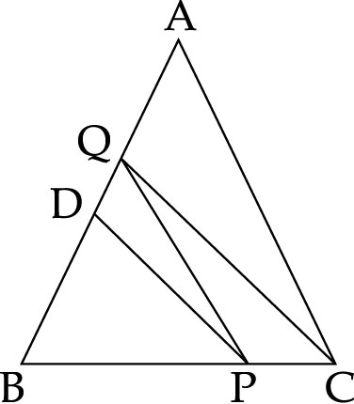 |  |  |  |  |  |  | 4
 | 22 | 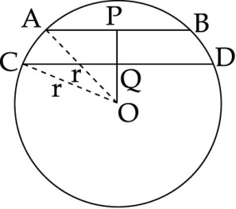  In the given figure, O is the centre of a circle of radius r cm, OP and OQ are perpendiculars to AB and CD respectively and PQ1cm. If ABCD, AB6 cm and CD8 cm, determine r. |  |  |  |  |  |  | 4
 | 23 | Construct a Δ ABC in which BC 8 cm, ∠B30 and ABAC 3.5 cm. |  |  |  |  |  |  | 4
 | 24 | EFGH is a rectangle. A, B, C and D are midpoints of the sides EF, FG, GH and EH respectively. Show that ABCD is a rhombus. |  |  |  |  |  |  | 4
 | 25 | The "Caring old people organisation" needs money to build the old age home which requires 164000 bricks. Bricks measure 10 cm8 cm 4 cm and cost of brick depends on its volume at the rate of ` 1 per 100 cm3. It requires 4 cylindrical cans of paint of radius 14 cm and height 30 cm. The cost of paint is ` 1 per 20 cm3. How much money is required by organisation ? If “A company gives the money to organization” then, what common value is depicted by A company and organisation. |  |  |  |  |  |  | 4
 | 26 | A spherical ball of lead, 3 cm in diameter is melted and recasted into three different sized spherical balls. Find the diameter of the third ball if the diameter of the first two balls is 1 cm and 1.25 cm. |  |  |  |  |  |  | 4
 | 27 | A wall 6 m long, 5 m high and 0.5 m thick is to be constructed with bricks, each having length 25 cm, breadth 12.5 cm and height 7.5 cm. Find the number of bricks required to construct the wall, if it is given that cement and sand mixture occupy of the volume of the wall. |  |  |  |  |  |  | 4
 | 28 | A die is rolled 25 times and outcomes are recorded as under :  Outcomes 1 2 3 4 5 6  Frequency 9 4 5 6 1 0  It is thrown once again. Find the probability of getting :  (a) an even number  (b) a multiple of 3  (c) a prime number  (d) a number neither prime nor even. |  |  |  |  |  |  | 4
 |  | Section E
 | 29 | The median of the following observations arranged in ascending order is 13. Find the value of ‘x’.  3,7,8, x + 1, x+3, 12,15,18 |  |  |  |  |  |  | ,3
 | 30 | The mean age of 20 students is 15 years. If the age of the teacher is included, then mean age becomes 17 years. Find the age of the teacher. |  |  |  |  |  |  | 3
 | 31 | The following table gives the distribution of students of two sections according to the marks obtained by them. |  |  |  |  |  |  | 4
 |  | SECTION A |  |  | SECTION B
 |  | MARKS | FREQUENCY |  | MARKS |  | FREQUENCY
 |  | 0-10 | 2 |  | 0-10 |  | 5
 |  | 10-20 | 12 |  | 10-20 |  | 11
 |  | 20-30 | 18 |  | 20-30 |  | 15
 |  | 30-40 | 13 |  | 30-40 |  | 12
 |  | 40-50 | 5 | 40-50 |  | 7

