Sample Question Paper 3
Class XII
Biology (044)

Time allowed: 3hrs. Maximum Marks: 70

General Instructions:
1. There are a total of 26 questions and five sections in the question paper. All questions are compulsory.
2. Section A contains question number 1 to 5, Very Short Answer type questions of one mark each.
3. Section B contains question number 6 to 10, Short Answer type I questions of two marks each.
4. Section C contains question number 11 to 22, Short Answer type II questions of three marks each.
5. Section D contains question number 23, Value Based Question of four marks.
6. Section E contains question number 24 to 26, Long Answer type questions of five marks each.
7. There is no overall choice in the question paper, however, an internal choice is provided in one question of two marks, one question of three marks and all three questions of five marks. An examinee is to attempt any one of the questions out of the two given in the question paper with the same question number.
Section A
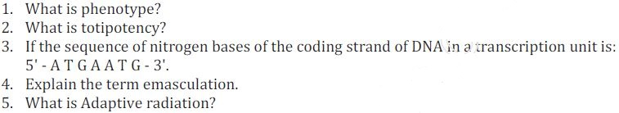Section B
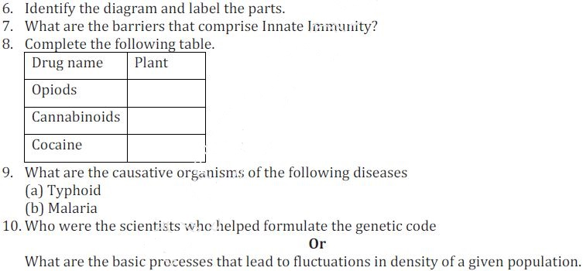

Section C
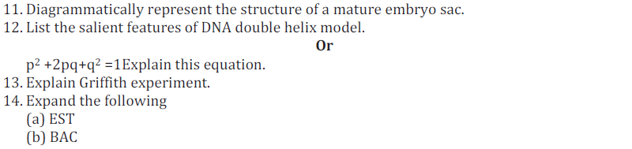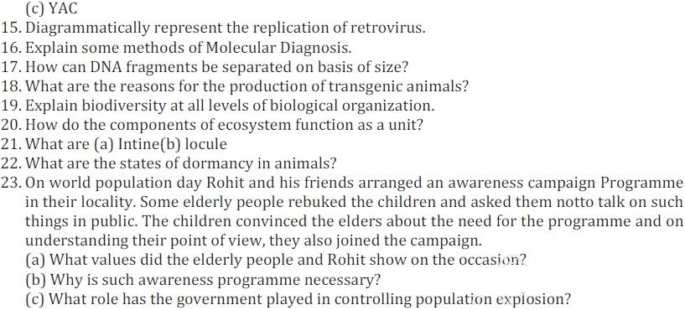
Section D
