 |  | PRACTICE PAPER-2
SOCIAL SCIENCE
Class – X

Time : 3 hours M.M: 90

General Instructions :
(i) All questions are compulsory.
(ii) Marks are indicated against each question.

 | 1 | Why did Khilafat Movement begin ? | 1
 | 2 | Where are Bailadila hills located and why are they called so ? | 1
 | 3 | Which challenge to established democracies ensures more participation of women and minority groups in a democratic country ? | 1
 | 4 | What is the symbol of Bahujan Samaj Party | 1
 | 5 | State the meaning of democracy. | 1
 | 6 | Write the main role of WTO | 1
 | 7 | Write any one objective of consumer awareness | 1
 | 8 | Write two advantages of self help group | 1
 | 9 | Describe the main features of Lahore Congress Session of December  1929 ? | 3
 | 10 | How was history reinterpreted to instill nationalism ? | 3
 | 11 | Differentiate between the concept of a modern state and a nation state. How did the sense of common identity develop in Europe ? | 3
 |  | OR
 |  | Who was Paul Bernard ? According to him why did the economy of the colonies need to be developed ? | 3
 | 12 | Name any six major seaports located on the east coast of India. | 3
 | 13 | Distinguish between industries on the basis of their main role with examples. | 3
 | 14 | ‘India should harness the geo-thermal energy to meet the growing consumption of energy’. Explain the statement with three facts. | 3
 | 15 | What category of challenge did Nepal face during 2006 ? Support your answer with suitable examples. | 3
 | 16 | Describe any three functions of political parties. | 3
 | 17 | Which one do you prefer – quick decision of dictatorship or slow decision of democracy and why ? | 3
 | 18 | Mention any three functions of consumer protection council. | 3
 | 19 | Mention any six items that can be kept as a collateral against loans ? | 3
 | 20 | Impact of globalization is not always beneficial for a country. Explain the values hampered due to this. | 3
 | 21 | Describe the different factors that shaped the political situation in the late  1920s. | 5
 | 22 | What happened during the years following 1815 when the fear of repression drove many liberal-nationalists underground ? Explain. | 5
 |  | OR
 |  | Explain any five reasons for the plague to strike the newly built Hanoi in 1903 | 5
 | 23 | “Give reasons as to why the ideal location of sugar mills is near sugar caneproducing areas”. Support the statement with reasons. | 5
 | 24 | “Pipeline transport network is on the increase now a days.” Give five arguments in favour of the statement. | 5
 | 25 | “The best laws are those which empower people to carry out democratic reforms.” Justify the statementwith suitable argument. | 5
 | 26 | DescribeBolivia’s water war and its consequences. | 5
 | 27 | Name and explain the functions of the different consumer courts in India ? | 5
 | 28 | Explain the role of money in an economy. | 5
 | 29  30 | Two features A and B are shown in the given political outline map of India. Identify these features with the help of following information and write their correct names on the lines marked on the map.  (A) A nuclear power plant.  (B) An iron and steel plant.  On the same political outline map of India, locate and label the following feature with appropriate symbol.  (C) Indira Gandhi international airport.  (D) Congress session of 1929  (E) Chauri-Chaura ( F ) Amritsar  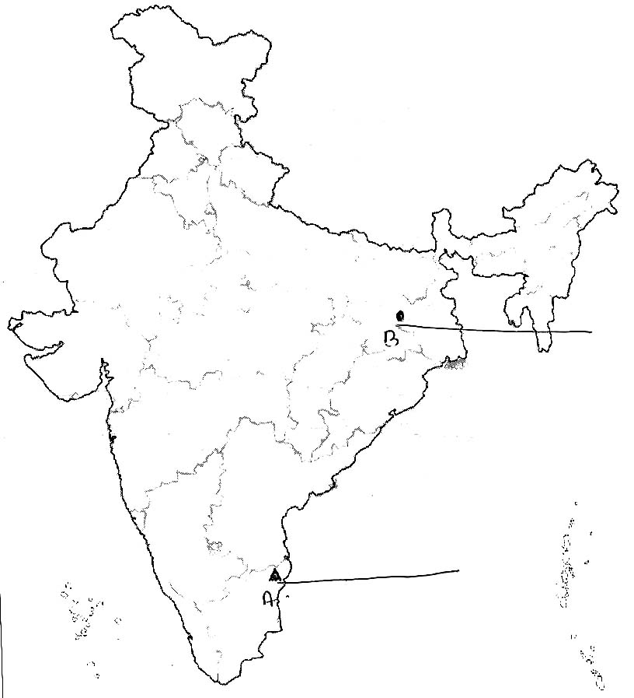 | 2  4
 |  | -

