PRACTICE PAPER 1
SOCIAL SCIENCE
CLASS-VIII
M.M.90
GENERAL INSTRUCTIONS:
1.There are 31 questions in all.
2. Marks for each question are indicated against it.
3. All the questions are compulsory.
4. Write the same question number as given in the question paper while answering a question in your answer book.
5. i) Answers to MCQ of 1 mark should be out of (a),(b),(c) or (d) only.
ii) Answer to each question of 3 marks should not exceed 60 words each.
iii) Answer to each question of 5 marks should not exceed 120 words each.

A. Tick the correct option: 1x10=10
1. Mineral and energy resources provide the foundation for:
a) infrastructural development
b) economic and industrial development
c) educational development
d) physical development
2.Which type of farming is also called ‘SLASH & BURN’ Agriculture ?
a) commercial agriculture b) Plantation agriculture
c) Shifting agriculture d) Extensive agriculture
3. Which age group of people is considered as productive population ?
a) people below 40 years b) people between 15-59 years
c) people between 15-50 years d) people between 14-70 years
4. Who initiated the Wardha scheme of education ?
a) Mahatma Gandhi b) Raja Ram Mohan Roy
c) Shri Narayan Guru d) Jyotiba phule
5. Which case related to the following subjects is a civil case ?
a) Marriage b) Robbery
c) Murder d) Cheating
6. who was considered the “Prophet of Modern Andhra Pradesh”?
a) Periyar EV Ramasamy b) Shri Narayan Guru
c) Raja Ram Mohan Roy d) Veerasalingam Kandukuri
7. By which act did the British imprison Indians without a trial ?
a) The Govt of India act 1919
b) Charter Act of 1813
c) Rowlatt act of 1919
d) The government of India act 1935
8.A traditional Islamic Educational institution is known as a:
a) Pathshala b) Madarsa
c) Convent d) Gurukul
9. Musahars belong to which states ?
a) bihar & himachal Pradesh b) bihar & Madhya Pradesh
c) bihar & uttar Pradesh d) bihar & Andhra Pradesh
10. Harijans were known as:
a) Priests b) Untouichables
c) Artisans d) Farmers
11. While comparing the agricultural practices of USA with INDIA, which such practice you find more effective & why ? (3)
12. Why “Plantation agriculture” is the best type of commercial farming ? (3)
13. ‘Manufacturing industries add value to the commodity’ . Justify the statement by giving three examples in support of your answer (3).
14.What are the basic features of India’s foreign policy ? (3)
15. How and why has Bangalore become the hub of IT industries in india ? (3)
16.who is called the founding father of iron & steel industry in india ? Why did he choose Jameshdpur for the establishment of his first industry ? (3)
17. What were the main provisions of wood’s dispatch of 1854 ? explain. (3)
18. Describe the major proposals made by cabinet mission. What was the attitude of the muslim league towards it ? (3)
19.What are the basic features of India’s Foreign policy ? (3)
20.What do you mean by collective responsibility of council of ministers? (3)
21. What are subordinate courts ? who supervises the subordinate courts ? Give two examples of subordinate courts ? (3)
22. How do industries & government policies affect the distribution of population in india ? (5)
23. Which two reasons were mainly responsible for the partition of Bengal ? What was the reaction of Indians (5)
24. What is meant by energy crisis ? why is it important to solve such a crisis ? suggest any three measures to conserve energy resources ? (5)
25. What is meant by sex ratio ? Why is the sex ratio not balanced in india ? explain. (5)
26.Why did gandhiji launch the Quit India Movement ? Explain any three results of quit india movement ? (2+3=5)
27.What is meant by Marginalization ? Who are responsible for marginalization of Dalits and how ? (2+2+1=5)
28.What is the composition of the council of ministers ?How the council of minister is appointed ? (1+4=5)
29.State any five key features of the Indian independence act,1947. (5)
30.i) .Iocate these features with the help of following information (3)
(A) City where Jallianwala Bagh Massacre took place.
(B) The place where Mahatma Gandhi broke salt law.
ii) On the same outline political map of india locate & lable the following place:
(C) The place to which Periyar E.V Ramasamy belonged.

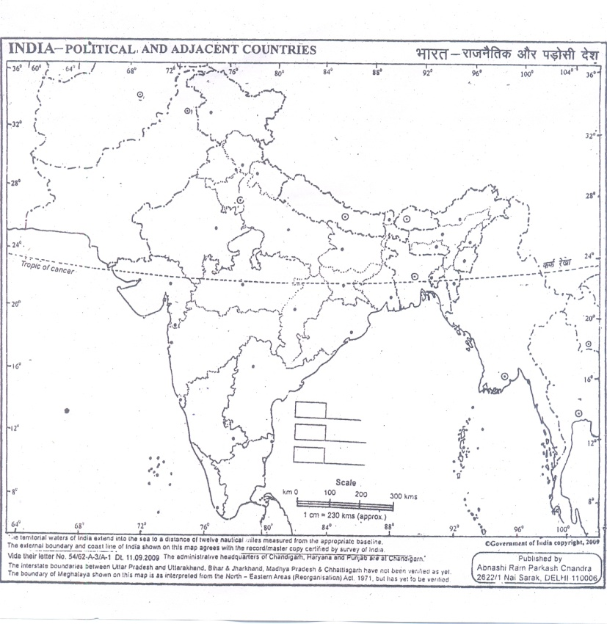
31. Iocate these features with the help of following information in the world map. (4)
(A) An important iron & steel manufacturing country of Africa.
(B) An important cotton textile producing country of Africa.
ii) On the same outline political map of world, locate & lable the following with appropriate symbols:
(C) South Africa- An important copper producing country.
(D) Brazil- An important Bauxite producing country.
