 |  | PRACTICE PAPER - 1
SUMMATIVE ASSESSMENT – II
SOCIAL SCIENCE
Class – IX

Time : 3 hours M. M : 90

General Instructions :

(i) The question paper has two sections (Section A and Section B) with 30 questions in all. All questions are compulsory.
(ii) Marks are indicated against each question.

 |  | SECTION - A
 | 1 | Why do the Konkani peasants welcome the Dhangar cattle herders ? | 1
 |  | OR
 |  | During the colonial rule in India from which type of forests could the villagers take wood for their personal use ? | 1
 |  | OR
 |  | What did 16th century enclosures promote ? | 1
 | 2 | How many bio-sphere reserves have been set up in our country ? | 1
 | 3 | What is meant by forced labour or begar. | 1
 | 4 | Name the party formed by Chaudhary Devi Lal? | 1
 | 5 | When does a bill become a law ? | 1
 | 6 | Where did devastating famine occur in India ? | 1
 | 7 | What is meant by availability of food ? | 1
 | 8 | Who is the most vulnerable to food insecurity ? | 1
 | 9 | How did the colonial laws and regulations reshape the social relationships of the Maasai herder ? | 3
 |  | OR
 |  | Which Indian forest communities rebelled against the forest rules and under whom ? | 3
 |  | OR
 |  | What was the cause of conflict between the British government and the Indian peasants ? | 3
 | 10 | How was the Eton public school linked to cricket by the English ?  OR | 3
 |  | Which clothes were reserved for the Royalty in France ? How were they different from the clothes of others? | 3
 | 11 | ``The balance of power in cricket shifted from London to Dubai.'' Support the statement with any three suitable arguments. | 3
 |  | OR
 |  | What were the main causes of change in clothing in India during colonial period ? | 3
 | 12 | Which season is prevalent in the month of October in India? State any two weather conditions of this season. | 3
 | 13 | How is health an important aspect of population composition ? Explain. | 3
 | 14 | Give an account of the biodiversity of India. | 3
 | 15 | Which values should be maintained by the Election Commission of India during election process ? | 3
 | 16 | Describe the composition of the Indian Parliament? | 3
 | 17 | Describe any three rights of the people of south Africa ehich are not available to the citizens of India. | 3
 | 18 | How does social composition play an important role in food security of the  country ? | 3
 | 19 | Mention the reasons behind maintaining of huge stocks of food grains in India. | 3
 | 20 | Describe any three negative effects of increase in Minimum Support Price (MSP) of food grains in India. | 3
 | 21 | Who are the pastoral nomads? Describe any four features of them. | 5
 |  | OR
 |  | Describe the origin and spread of the Saminist movement. | 5
 |  | OR
 |  | What problems did expansion of wheat cultivation face after the coming of new technology in the USA ? Explain. | 5
 | 22 | Differentiate between the views of Thomas Arnold, the headmaster of Rugby School, and Mahatma Gandhi on the value of cricket in education. | 5
 |  | OR
 |  | What restrictions did the people of France face about their clothing before the French Revolution ? Explain. | 5
 | 23 | “The sex ratio has generally been declining since 1951 in India.” Support the statement. | 5
 | 24 | Give description of any five medicinal plants. | 5
 | 25 | Compare the position of the Prime Minister of the majority party and the Prime Minister of the coalition government? | 5
 | 26 | Describe minimum conditions for democratic elections? | 5
 | 27 | Two items A and B are shown in the given political outline map of India. Identify these items with the help of following information and write their correct names on the lines marked on the map.  (A) The place : from where forest rebellion started.  (B) The state to which Gonds belong.  On the same political outline map of India, locate and label the following item with appropriate symbol.  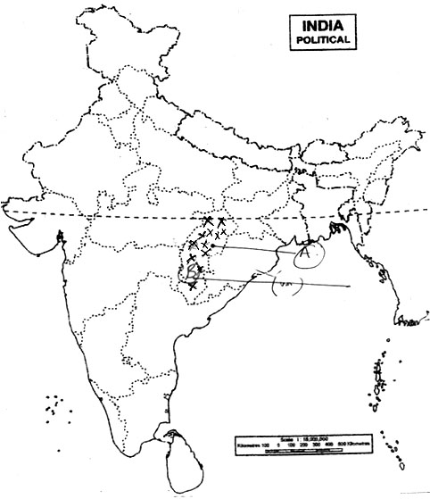  (C) Assam where tea plantation were formed during British rule. | 3
 |  | OR
 | 27b | Two items A and B are shown in the given political outline map of India. Identify these items with the help of the following information and write their correct names on the lines marked on the map.  (A) A state where local traders were offering much higher prices of opium to peasants.  (B) The port city from where larger volume of opium flowed out.  On the same political outline map of India, locate and label the following item with appropriate symbol.  (C) State where armed band of traders were found doing opium trade in 1820s.  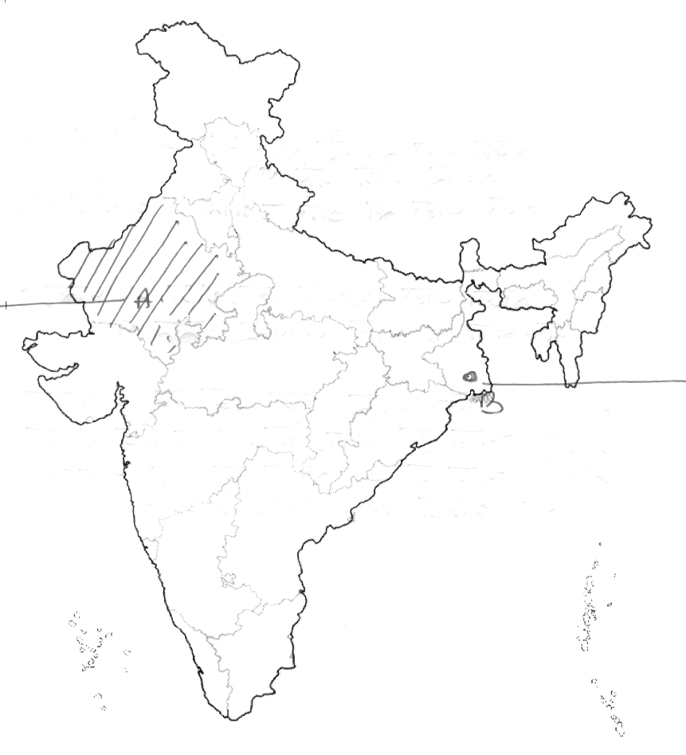 | 3
 | 28 | On the political outline map of India locate and label the following feature with appropriate symbol. (A) A Wildlife Sanctuary.  (B) A type of vegetation  (C) The state having the highest density of population.  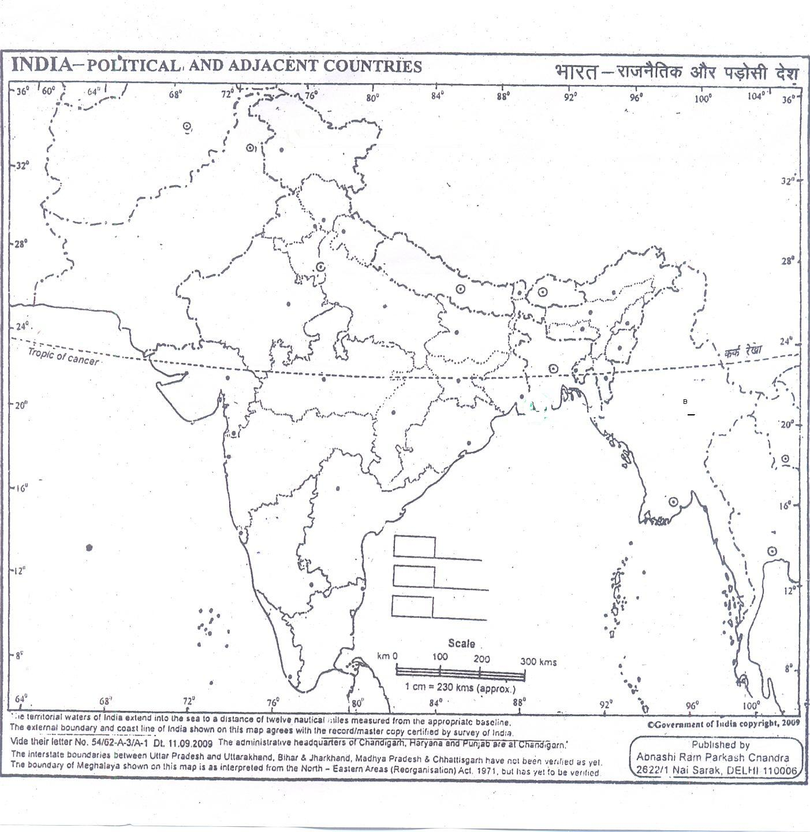 | 3
SECTION - B (OTBA)
THEME-1
 | 29 | “Deficient monsoon has initiated the need of technological innovations & awareness”.Explain. | 5
 | 30 | How is Monsoon type of climate a set back to India? | 5

