CLASS VIII
MATHS
PRACTICE PAPER- 3
SECTION-A
- Find the value of (0.03125)^{-2/5}.
- Find degree of polynomial (z²+5) (z²-6).
- In the word ‘MATHS’ which letter shows rotational symmetry of order 2?
- Give the order of rotational symmetry.

SECTION-B
- Find the value of x for
2^{x} + 2^{x} + 2^{x} = 192
- Find value of {4 × 81^{-1/2} (81^{1/2} + 81^{3/2)}}
- Divide (-3x² + √3x) by √3x
- Using factor method, divide the polynomial
x² - 10x + 16 by x – 2
- Solve the following equation for x

$${\left(\frac{5x-4}{2.4x+6}\right)}^{ }=\frac{-5}{3}$$

- Write order and angle of rotational symmetry of equilateral triangle.

SECTION – C

- Simplify and express the answer with positive indices
$\{ \sqrt[3]{x\text{4}y}$ + $\frac{1}{\sqrt[3]{xy^{7}}}$ }⁻⁴
- Calculate the CI on Rs. 24000 for 6 months if interest is payable quarterly at the rate of 8% p.a.

- Using long division method, show that (2q-1) is a factor of
4q³ – 6q – 4q + 3
- The sum of three consecutive multiplies of 8 is 888. Find these multiples.
Or
The difference between two positive integers is 30. The ratio of integers is 2:5. Find the integers.

- The length of rectangle is greater than breadth by 3. If length is increases by 9cm and breadth reduced by 5cm such that area remains same. Find the dimension of rectangle.

- ABCD is parallelogram. AP bisects $∠A$ and CQ bisects $∠C$. P lies on CD and Q lies on AB. Show that
- AP parallel CQ
- AQCP is a parallelogram.

- ABCD is a rectangle in which DP and BQ are perpendiculars from D and B on diagonal AC. Show that
- ADP $≅$CBQ
- DP = BQ

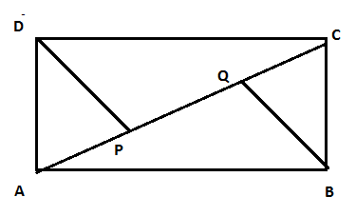

- Construct a quadrilateral ABCD in which
AB = 5.5cm, BC = 6cm, CD = 6.5cm and
Diagonal AC = 8cm and BD = 7.5cm

- There are 25 chalks in a box. 88 are yellow chalks, 11 are blue and rest are white. You are asked to pick a chalk from box without looking. What is probabilities of
- Getting a yellow chalk
- Getting a blue chalk
- Getting a white chalk.

- Find fraction of circle representing each of information given below
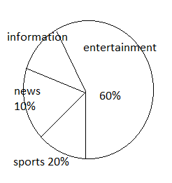
SECTION – D

- If $5^{x+1}$ – $5^{x}$= 500 then find the value of $4^{x}$.

- The SI on a certain sum of money for 2 years at 5$1/2$ % on Rs. 6600. What will be the CI on that sum at same rate for same time period?

- The annual rate of growth in population of a city is 8%. If present population is 1,96,830. What was the population 3 years ago.?

- The difference between CI and SI on a certain sum of money at 15% p.a. for 3 years is Rs. 283.50. Find the sum.

- Ramprakash died leaving one-fourth of his property for his son, one fourth for his daughter and the rest for his wife. His wife gave one-third of her property and Rs. 5000 to the organisation which promotes women’s skill development. If the amount she gave to the organisation was Rs. 15000, find the total value of the property and the amount each person got? What value is shown by the wife?

- Divide and check your result
125 – 225x + 135x² – 27x³ by 5 – 3x
- Two adjacent sides of parallelogram are in ratio 3:8 and its perimeter is 110cm. find the sides of parallelogram.

- A pair of adjacent sides of rectangle are in ratio 3:4. If its diagonal is 20cm. Find the length of sides and perimeter of rectangle.

- Using ruler and compass, construct a quadrilateral ABCD in which
AB = 5cm, BC = 6cm, CD = 6.5cm, $∠B$ = 105 and $∠C$ = 75
- The following numbers were written in separate slips and mixed in a bag. You are asked to pick up a slip, what is probability of getting
- An even number
- A factor of 36
- A one-digit number
- A multiple of 3

- Choice of food for a group of people is given below. Prepare a pie chart for the given data.
Food | North Indian | South Indian | Chinese | others
No. of people | 30 | 40 | 25 | 25

- The electricity bills of 25 houses of a certain locality for a month are given below
324 630 700 584 617 674 400 754 356
776 365 596 435 745 506 565 548 763
736 472 780 378 570 685 312

Prepare frequency table taking class intervals 300-400, 400-500 etc.
Also draw a histogram.

