Sample paper- 1
Class XIth
Biology
Time: 3 hrs MM: 70
General instructions:
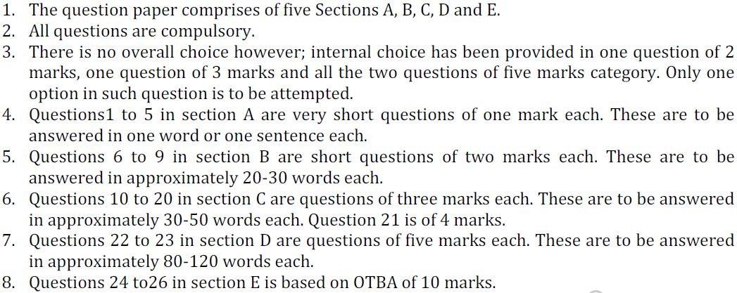

Section A

Section B
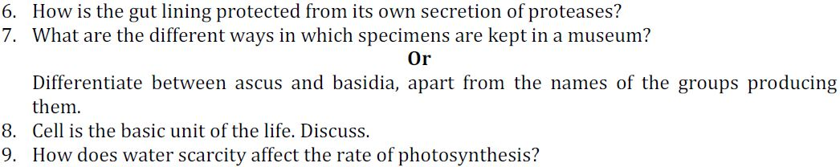
Section C
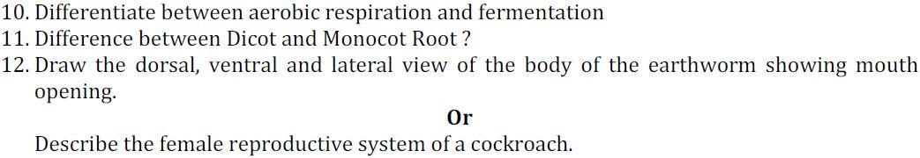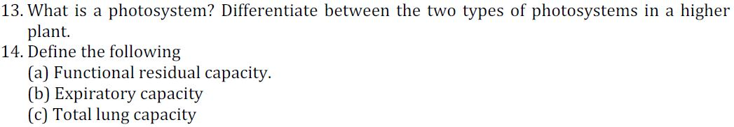

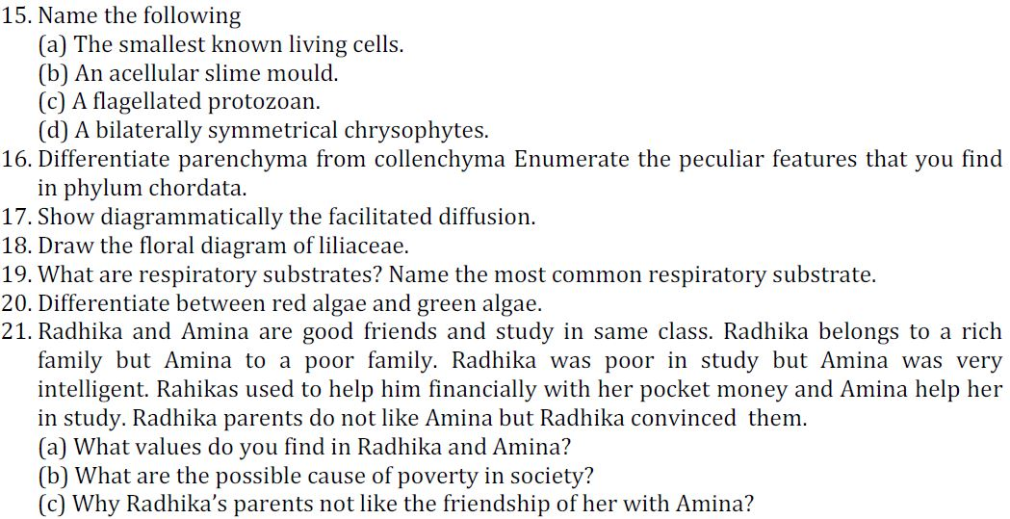
Section D
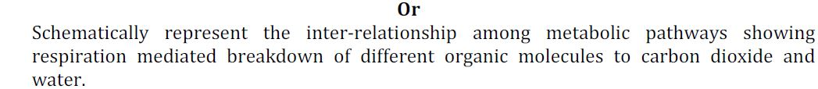
24. Classify the sub: phylum vertebrata up to classes & write down the features of class Amphibia
Or
Give the occurrence of following organs in organisms & write down one feature of their phylum.
- Comb plate
- Flame cells
- Radula
- Operculum
- Maipighian tubules
Section E

