SUMMATIVE ASSESSMENT – II (2014-15)
â´·¤çÜÌ ÂÚUèÿææ -II
SCIENCE /çß™ææÙ
Class – X /·¤ÿææ - X

Time allowed : 3 hours Maximum Marks : 90

General Instructions :
(i) The question paper comprises of two Sections, A and B. You are to attempt both the sections.
(ii) All questions are compulsory.
(iii) There is no choice in any of the questions.
(iv) All questions of Section-A and all questions of Section-B are to be attempted separately.
(v) Question numbers 1 to 3 in Section-A are one mark questions. These are to be answered in one word or in one sentence.
(vi) Question numbers 4 to 6 in Section-A are two marks questions. These are to be answered in about 30 words each.
(vii) Question numbers 7 to 18 in Section-A are three marks questions. These are to be answered in about 50 words each.
(viii) Question numbers 19 to 24 in Section-A are five marks questions. These are to be answered in about 70 words each.
(ix) Question numbers 25 to 33 in Section-B are multiple choice questions based on practical skills. Each question is a one mark question. You are to select one most appropriate response out of the four provided to you.
(x) Question numbers 34 to 36 in Section-B are questions based on practical skills. Each question is a two mark question.

 |  | Öæ»-¥ /SECTION-A
 | 1 | Give the structural formula of alkene with 3 carbon atoms. | 1
 | 2 | Where does the human female reproductive system implantation of embryo takes place ? | 1
 | 3 | Identify two local industries which pollute the local water bodies by throwing untreated waste. | 1
 | 4 | Name the eye part where image is formed and also mention the type of image formed by the eye lens on this part. | 2
 | 5 | Mention any four reasons of deforestation. | 2
 | 6 | Accumulation of harmful chemicals in our bodies can be avoided. Explain how this can be achieved. | 2
 | 7 | Carbon has the unique property to form bonds with other atoms of carbon.  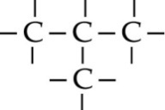  fig. A  (i) Name the characteristic property of carbon as depicted in the given fig A.  (ii) Give reason for this unique property of carbon.  (iii) Draw the structure of cyclohexane. | 3
 | 8 | Explain the formation of covalent bond by electron structure for Hydrogen, oxygen, nitrogen molecules. | 3
 | 9 | An element A is in the third group of periodic table. Write the chemical formula of its oxide and chloride. | 3
 | 10 | The atomic radii of elements of a period are 88 pm, 111 pm, 66 pm, 152 pm and say 77 pm.  (i) Which element will be on the extreme left of the period ?  (ii) Which element will be on the extreme right the period ?  (iii) Which element has the largest atom ? | 3
 | 11 | Homologous organs are different from analogous organs.  (a) Mention the two basic characteristics that decide about analogy and homology between the two organs.  (b) On what basis is the classification of organisms into Prokaryotic and Eukaryotic done ? | 3
 | 12 | A child questioned his teacher that why do organisms resemble their parents more as compared to grand parents. In which way will the teacher explain to the child ? | 3
 | 13 | a) Identify the incorrect step in the following and correct it.  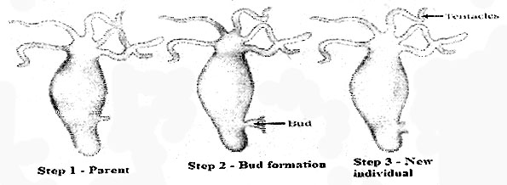  (b) Which process is depicted in the above diagram ? Name the organism. | 3
 | 14 | DNA content has the tendency to double itself during sexual reproduction due to combining of the genetic materials from two parents. How can the problem of DNA doubling be solved to maintain the consistency of the genetic material throughout the species ? | 3
 | 15 | (a) What are hybrids ?  (b) Give a term for the following :  (i) Externally exhibited trait  (ii) Traits developed by genes | 3
 | 16 | Given below are incomplete diagrams for correction of eye defects. Complete these diagrams to show the image formation and name the defects which are corrected in each case.  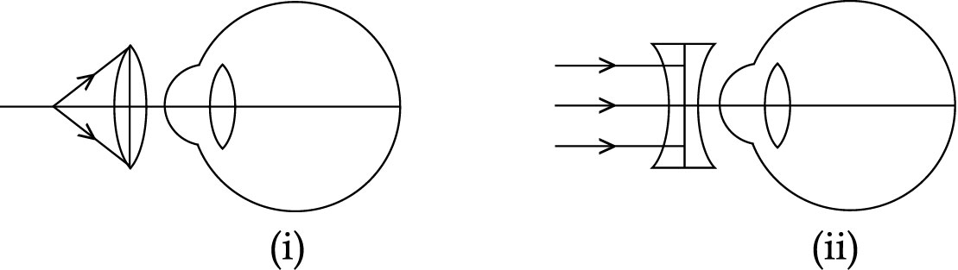 | 3
 | 17 | A 10 cm tall object is placed perpendicular to the principal axis of a convex lens of focal length 30 cm. The distance of the object from the lens is 20 cm. Find the position, nature and size of the image formed. | 3
 | 18 | The teacher was discussing with her students about fuels in class. She told them about PCRA’S (Petroleum Conservation Research Association) guidelines to save petrol and diesel while driving. Amit was coming to school with his mother. At traffic signal when the light was red he suggested to turn off the engine.  (i) Fossil fuels are obtained from nature, then why do we need to conserve them ?  (ii) How can we contribute in saving fossil fuels ?  (iii) What values are possessed by Amit ? | 3
 | 19 | What are esters ? Mention any two uses of them. Distinguish between esterification and saponification processes giving the relevant chemical equations. | 5
 | 20 | (a) When a pesticide is sprayed on a population of insects, all insects do not get killed but few of them survive. Give reason  (b) When is a recessive trait capable of expressing itself ? Write its expression with respect to height of plant (genotype). | 5
 | 21 | Draw a longitudinal section of a flower and label any six of the following parts :  anther, filament, petal, sepal, stigma, style, ovary (any six) | 5
 | 22 | Compare the refraction of light through a rectangular glass slab and a triangular glass prism. Draw diagrams showing path of light ray in each case. | 5
 | 23 | Explain the mechanism of micelle formation | 5
 | 24 | Explain the phenomenon of twinkling of stars | 5
 |  | Öæ»-Õ / SECTION - B
 | 25 | The common salt helps in separating soap from solution after saponificationby :  (a) decreasing solubility of soap  (b) increasing solubility of soap  (c) decreasing density of soap  (d) increasing density of soap | 1
 | 26 | The most suitable temperature of hot water bath during Saponification process is :  (a) below 50C (b) about 85C  (c) above 100C (d) room temperature | 1
 | 27 | Soap does not form lather in :  (a) homogeneous solution of calcium chloride in water  (b) tap water  (c) rain water  (d) river water | 1
 | 28 | A student obtains a blurred image of an object on a screen by using a concave mirror. In order to obtain a sharp image on the screen, he will have to shift the mirror :  (a) towards the screen.  (b) away from screen.  (c) either towards or away from screen depending upon the position of the object.  (d) to a position very far away from the screen. | 1
 | 29 | A teacher gives a convex lens and a concave mirror of focal length about  12 cm each to her student and asked her to find their focal length by obtaining the image of a distant object. The student used a distant tower as the object and obtained its sharp image one by one on a white screen. The distances I1 and I2 between the lens/mirror and the screen in the two cases and the nature of their respective images are likely to be :  (a) (12 cm, 12 cm) and (erect , erect)  (b) (12 cm, 24 cm) and (erect , erect)  (c) (12 cm, 24 cm) and (inverted , inverted)  (d) (12 cm, 12 cm) and (inverted , inverted) | 1
 | 30 | A student recorded the following sets of observations while performing an experiment "To trace the path of a ray of light passing through a glass slab for different angles of incidence".  S. No Angle of incidence (∠i) Angle of refraction (∠r) Angle of emergence (∠e)  I 41 45 41  II 40 38 38  III 45 41 40  IV 45 41 45  The correct observation is recorded at S. NO :  (a) I (b) II (c) III (d) IV | 1
 | 31 | If a light-ray is allowed to fall on the triangular glass prism at different angles of incidence(but not less than 30) then for each angle of  incidence :  (a) the angle of deviation will be different.  (b) the angle of deviation will be same.  (c) angle of deviation only increases with increase in angle of incidence.  (d) angle of deviation only decreases with increase in angle of incidence. | 1
 | 32 | Potato is a modified stem and sweet potato is a modified root. Both represent the relationship as :  (a) homologous (b) analogous  (c) vestigeal (d) rudimentary | 1
 | 33 | The part of the embryonic stem above the point of attachment of the cotyledon is called :  (a) Hypocotyle (b) Epicotyl  (c) Plumule (d) Hilum | 1
 | 34 | The following symbols A and B are usually shown on the bottle of commercial acetic acid. What does these symbols indicate ?  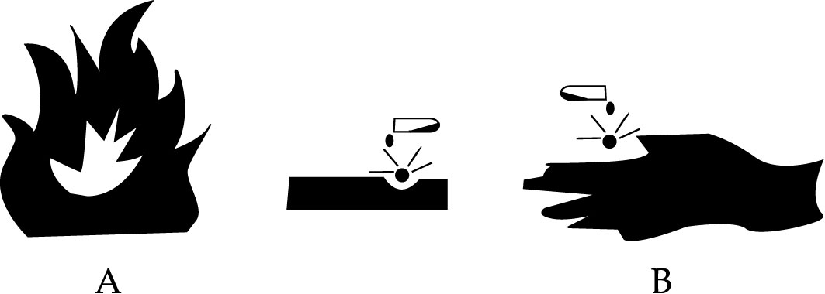 | 2
 | 35 | A student tried to observe the slide of binary fission in amoeba under a microscope. After focusing on the slide he was not able to get a clear view even after adjusting the diaphragm. Suggest two possible modes of adjustments of the microscope to get a clear view of the slide. | 2
 | 36 | In the following ray diagram.  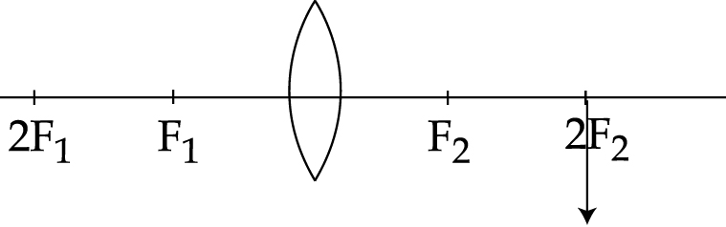  (i) What will be the position of the object ?  (ii) Compare the size of image A' B' with the object. | 2
 |  | -o0o0o0o-

