PRACTICE PAPER – II
MATHEMATICS
Class – IX
Time allowed : 3hours Maximum Marks : 90

General Instructions :
(i) All questions are compulsory.
(ii) The question paper consists of 31 questions divided into five sections A, B, C ,D and E. Section-A comprises of 4 questions of 1 mark each, Section-B comprises of 6 questions of 2 marks each, Section-C comprises of 8 questions of 3 marks each and Section-D comprises of 10 questions of 4 marks each. Section E comprises of two questions of 3 marks each and 1 question of 4 marks.
(iii) There is no overall choice.
(iv) Use of calculator is not permitted.

 |  | SECTION-A
 |  | Question numbers 1 to 4 carry one mark each.
 | 1 | If one is added to numerator and 4 is subtracted from denominator, the fraction becomes 1. Represent the statement as a linear equation in two variables. | 1
 | 2 | Find the value of k for which x = 0, y = 8 is a solution of | 1
 | 3 | Why we cannot construct a triangle of given sides as 5 cm, 5 cm and  10 cm ? | 1
 | 4 | Calculate the amount of air inside a conical tent with base radius 7 m and height 12 m. | 1
 |  | SECTION-B
 |  | Question numbers 5 to 10 carry two marks each.
 | 5 | PQRS is a parallelogram with diagonals PR and QS intersecting at a point E. If ar (ΔSEP)  ar (ΔQER)  12 cm2, find area of parallelogram PQRS. | 2
 | 6 | Draw any acute angle. Name as ∠XYZ. Bisect it using compass. | 2
 | 7 | In the figure, ABC is a triangle in which L is the mid-point of AB and N is a point on AC such that AN2CN. A line through L, parallel to BN meets AC at M. Prove that AMCN.  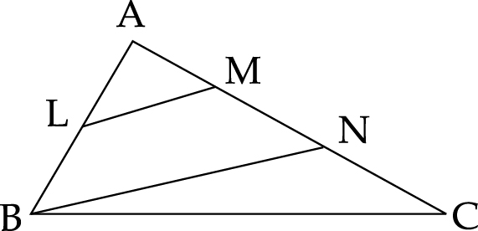 | 2
 | 8 | The length of the diagonal of a cuboid is 5cm and the sum of its length, breadth and height is 19 cm. Find its surface area. | 2
 | 9 | In a bottle there are 7 red buttons, 5 green buttons and 8 purple buttons. What is the probability that randomly drawn button from the bottle is a purple button ? If one extra green button is put inside the bottle, what will be the probability that randomly drawn button is purple ? | 2
 | 10 | The blood group of students from class IX are collected and recorded as below :  Blood group A B AB O  Number of Students 12 9 7 6  If a student is chosen at random find the probability that it is universal donor. (O group). | 2
 |  | SECTION-C
 |  | Question numbers 11 to 18 carry three marks each.
 | 11 | The parking charges for vehicles in Super Delhi Metro is ` 20 for the first two hours and ` 10 for subsequent hours. Assume total parking time to be x hours (where x≥ 2) and total parking charges as ` y. Write a linear equation to express the above relation and draw a graph. Find the parking charges for 5 hours from the graph. | 3
 | 12 | Draw the graph of two lines whose equations are 3x – 2y + 6 = 0 and x + 2y – 6 = 0 on the same graph paper. Find the area of triangle formed by two lines and x-axis. | 3
 | 13 | PQRS is a parallelogram whose diagonals meet at O. A line through O intersects PQ at A and RS at B. Show that ar (ΔAOP)  ar(ΔBOR)  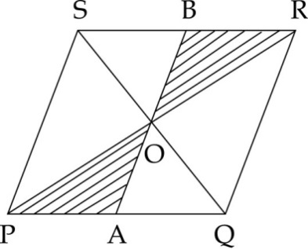 | 3
 | 14 | 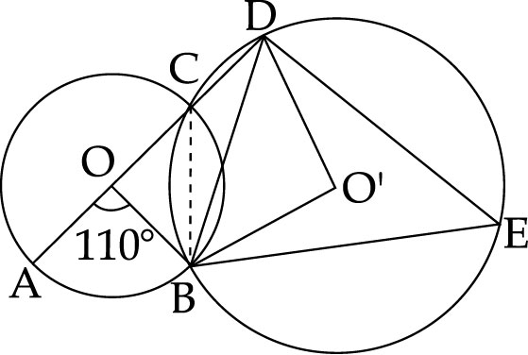  In the given figure, O and O' are centres of two circles and the circles intersect each other at points B and C. If AOCD is a straight line and ∠AOB110, find ∠BED and ∠BOD. | 3
 | 15 | Draw an angle of 90 using protractor. Now using compass and ruler,construct angles of 45 and 22. | 3
 | 16 | In a quadrilateral ABCD, ∠B∠D140, ∠B:∠D=1:3 and  ∠A : ∠C 5 : 6. Find all the angles of the quadrilateral. | 3
 | 17 | 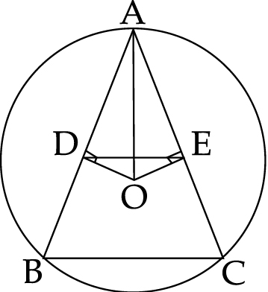  In the given figure, AB and AC are two chords of a circle whose centre is O. If OD⊥AB, OE⊥AC and AO bisects ∠DAE, prove that ΔADE is an isosceles triangle and ∠ABC∠ACB. | 3
 | 18 | The ratio of the volumes of two spheres is 27 : 8. Find the ratio of their surface areas. | 3
 |  | SECTION-D
 |  | Question numbers 19 to 28 carry four marks each.
 | 19 | çAamir scored 40 marks in a test, getting 3 marks for each right answer and losing 1 mark for each wrong answer. If number of questions attempted right by him is x and that attempted incorrectly is y, then write the linear equation which satisfies this data. Also draw the graph for the same. | 4
 | 20 | Write the equations of the lines p and r in following graph :  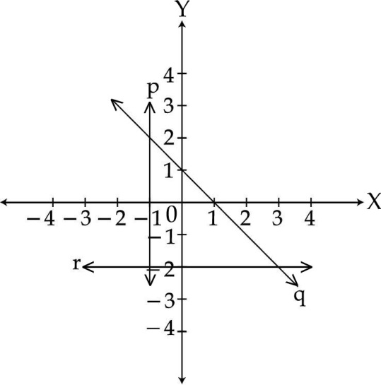  A student answered equation of line ‘q’ as xy1. Did he answer correctly ? Also, find the area enclosed between lines p, q and r. | 4
 | 21 | ABC is an equilateral triangle with perimeter 30 cm. P, Q and R are mid-points of AO, BO and CO as shown in figure. Find ar(PQR).  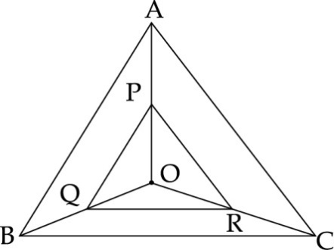 | 4
 | 22 | Prove that the line joining the midpoints of two parallel chords of a circle passes through the centre of the circle. | 4
 | 23 | Construct a Δ ABC, in which BC6.5 cm ABAC10 cm and ∠C60. | 4
 | 24 | Diagonal AC bisects ∠A of a parallelogram ABCD. Show that :  (i) It bisects ∠C also.  (ii) ABCD is a rhombus. | 4
 | 25 | In a women’s self-defense training camp, the soup is prepared in a cylindrical utensil of radius 10 cm. If there are 9 women in camp who take soup in hemispherical bowl of radius 5 cm then, how much soup should be made? What would be the height of cylindrical utensil of soup? What value is depicted here ? | 4
 | 26 | A conical tent is made of 4.5 m wide tarpaulin. Vertical height of the conical tent is 4 m and base radius is 3 m. Find the length of the tarpaulin used, assuming that 10% extra material is required for stitching margins and wastage in cutting (Take   3.14) | 4
 | 27 | The slant height and the diameter of the conical tomb are 25 m and 14 m respectively. Find the cost of constructing it at a rate of Rs. 25 per cubic metre and cost of whitewashing its curved surface area at Rs. 16 per metre square. | 4
 | 28 | A recent survey found that the ages of workers in a factory is distributed as follows :  Ages 14 - 23 24 - 33 34 - 43 44 - 53 54 and lbove  No. of Workers 38 27 86 46 3  If a worker is selected at random, find the probability that the age of the worker is :  (i) 44 years or more  (ii) under 43 years  (iii) in age group of 34-53 years.  (iv) under 54 but over 34 years | 4
 |  | SECTION-E
 | 29 | Find missing frequency ‘k’ from the following data.  X 5 10 15 20 25  F 2 8 k 10 5 | 3
 | 30 | The following data have been arranged in ascending order :  12,14,17,20,22,x,26,28,32,36  If the median of the data is 23 find x | 3
 | 31 | Construct the histogram and frequency polygon  Wages (in rs.) 4 -6 6-8 8-10 10-12 12-14 14-16  Frequency 2 8 15 12 2 1 | 4
 |  | -o0o0o0o-

