 |  | SAMPLE PAPER - 3
SUMMATIVE ASSESSMENT – II
SOCIAL SCIENCE
· Class – IX

Time allowed : 3 hours Maximum Marks : 90

General Instructions :

(i) All questions are compulsory.
(ii) Marks are indicated against each question.

 |  |  | SECTION - A
 | 1 |  | In which state is Bastar located ?. | 1
 | 2 |  | Name the areas having tropical evergreen forest in India. | 1
 | 3 |  | What is rule of law? | 1
 | 4 |  | How are candidates elected in India? | 1
 | 5 |  | What is meant by Reservation Policy ? | 1
 | 6. |  | About how many people died in famine of Bengal ? | 1
 | 7. |  | What is Buffer Stock? | 1
 | 8. |  | What is full form of NSSO? | 1
 | 9 |  | What was criminal tribes act of 1871 ? | 3
 |  |  | OR
 |  |  | What was Blandongdiensten system? | 3
 |  |  | OR
 |  |  | What was the impact of opium trade in China in mid eighteenth century ? | 3
 | 10 |  | How was decade of 1970s important in the history of cricket ? | 3
 |  |  | OR
 |  |  | What changes were introduced in women’s clothing due to world wars? | 3
 | 11 |  | What were the innovations introduced by Pakistan in bowling ? | 3
 |  |  | OR
 |  |  | What were sumptuary laws? | 3
 | 12 |  | Mention any three features of dry deciduous forests. | 3
 | 13 |  | What are the three broad categories of occupations on the basis of activies performed ? | 3
 | 14 |  | Explain three factors affecting flora &fauna in India? | 3
 | 15 |  | Why do most non - democratic countries also hold some kind of elections ? Which values are reflected by this practice ? | 3
 | 16 |  | Why do we need rights in a democracy? | 3
 | 17 |  | Why is it not easy to work in political institutions ? | 3
 | 18 |  | What is the role of cooperatives in food security? | 3
 | 19 |  | Differentiate between MSP and Issue Price. | 3
 | 20 |  | What are the dimensions of food security? | 3
 | 21 |  | How did life of pastoralists changed under colonial rule? | 5
 |  |  | OR
 |  |  | ‘The expansion of railways was a cause of deforestation’. Do you agree with the statement? Justify your answer with arguments. | 5
 |  |  | OR
 |  |  | What was open field system? | 5
 | 22 |  | “The establishment of the Parsi Gymkhana became a precedent for establishing clubs on the idea of religious community.” Justify the statement. | 5
 |  |  | OR
 |  |  | What were the responses to Gandhi’s call to adopt Khadi? | 5
 | 23 |  | What do mean by age structure? | 5
 | 24 |  | What is ecosystem? Explain the causes of disturbance in ecosystem? | 5
 | 25 |  | What makes elections democratic in India? | 5
 | 26 |  | What were the first written laws of cricket? | 5
 |  |  | The student has to attempt any one map question from question numbers 27a, 27b and 27c. Question no. 28 is compulsory. The maps are attached with the question paper.
 | 27a |  | Two items A and B are shown in the given political outline map of India. Identify these items with the help of following information and write their correct names on the lines marked on the map.  (A) State related to the pastoral community ; Gujjar-Bakarwal  (B) Place where camel fair is organised annually.  On the same political outline map of India, locate and label the following item with appropriate symbol.  (C) State where the Gaddi shepherd live.  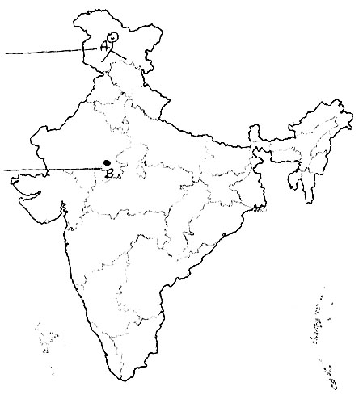 | 3
 |  |  | OR
 | 27b |  | Two items A and B are shown in the given political outline map of India. Identify these items with the help of following information and write their correct names on the lines marked on the map.  (A) A place where some tribes were labeled as criminal tribes.  (B) Area where forest reservation first started.  On the same political outline map of India, locate and label the following item with appropriate symbol.  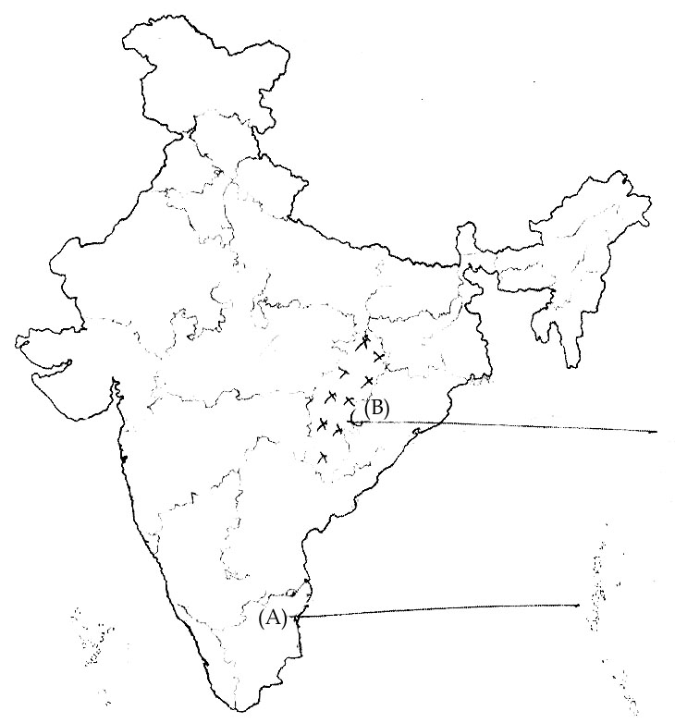  (C) State to which Alluri Sitaram Raju belongs | 3
 |  |  | OR
 | 27c |  | Two items A and B are shown in the given political outline map of India. Identify these items with the help of the following information and write their correct names on the lines marked on the map.  (A) A princely state where British didn't have control over opium trade.  (B) The region where peasants gave up opium cultivation for sugarcane.  On the same political outline map of India, locate and label the following items with appropriate symbol.  (C) The state where battle of Plassey took place.  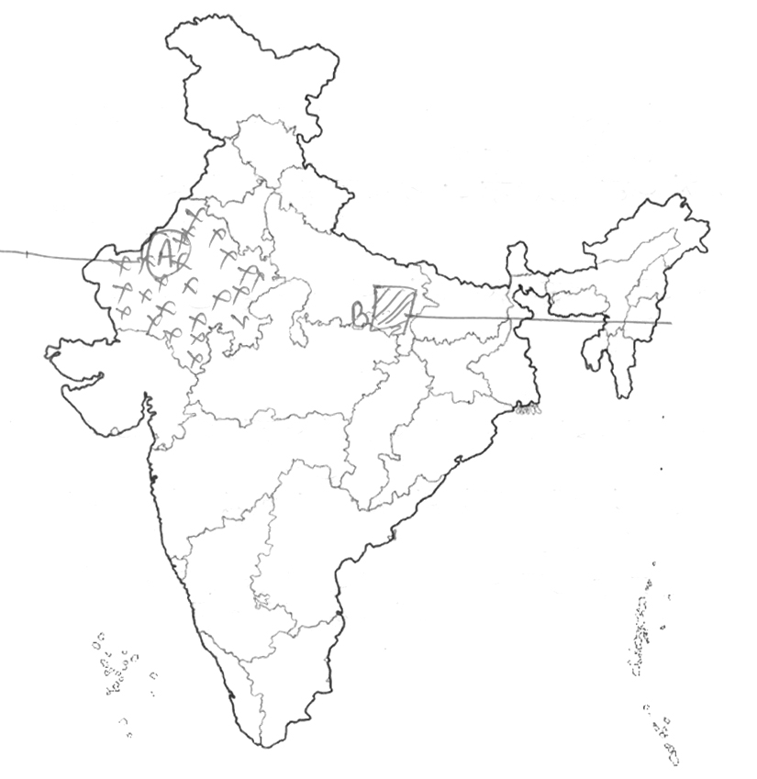 | 3
 | 28 |  | On the political outline map of India, locate and label the following items with appropriate symbols :  (A) Gir National Park.  (B) Evergreen forest on western coast  (C) The state having the lowest density of population.  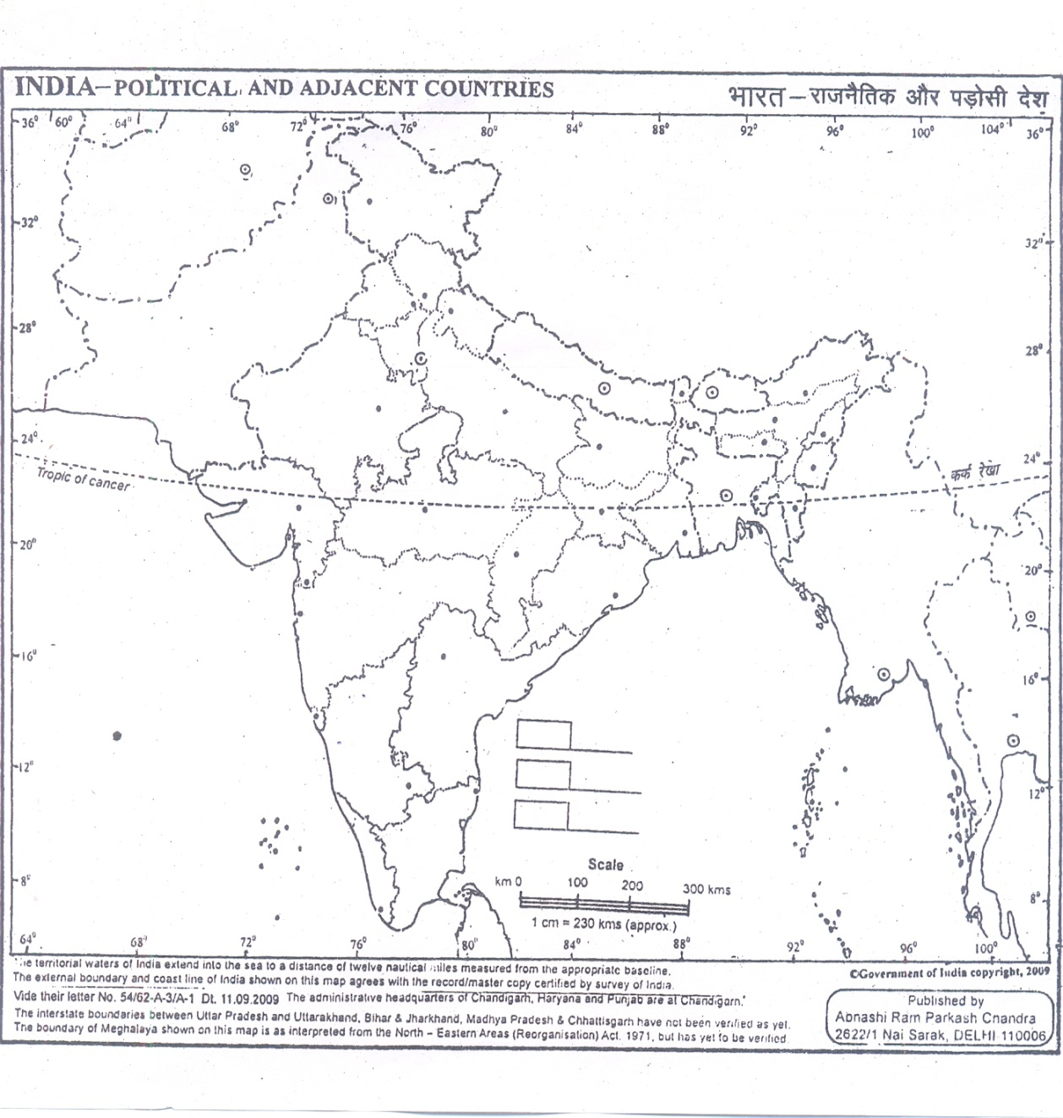 | 3
)
SECTION - B (OTBA)

Theme-2(Drought in Maharashtra……)
 | 29 |  | What can be various ways to tackle the problem of water scarcity? | 5
 | 30 |  | What are socio –economic implications of drought on farmers? | 5

