 |  | PRACTICE PAPER-2
S.A.-2
SOCIAL SCIENCE
Class – IX
Time : 3 hours M.M: 90
General Instructions :
(i) All questions are compulsory.
(ii) Marks are indicated against each question.

 |  |  | SECTION - A
 | 1. |  | The Raikas move between which two regions? | 1
 |  |  | OR
 |  |  | Name the river which flows across Bastar from east to west.
 |  |  | OR
 |  |  | When did the great Agrarian Depression occur in America?
 | 2. |  | Name the areas affected by tropical cyclones in India. | 1
 | 3. |  | What are rights? | 1
 | 4. |  | How are candidates elected in India? | 1
 | 5. |  | What is meant by Reservation Policy? | 1
 | 6.  7.  8. |  | Who has given international poverty line?  Who are more vulnerable to poverty within family?  Mention any two indicators of poverty as seen by social scientists? | 1  1  1
 | 9. |  | Why did colonial government want to rule over a settled population? | 3
 |  |  | What are the present developments in the field of forestry?
 |  |  | OR
 |  |  | What was dust bowl tragedy?
 | 10. |  | How were the amateurs different from the professionals in the game of cricket? | 3
 |  |  | OR
 |  |  | How did colonial rule influence Indian clothing?
 | 11. |  | How did Britain and Australia react to the innovations introduced by Pakistan? What was the ultimate outcome? | 3
 |  |  | OR
 |  |  | What differences in the social strata remained in the europian societies even after the end of sumptuary laws?
 | 12. |  | Name any two trees and two animals found in dry deciduous forests. How much rainfall does this region get? | 3
 | 13. |  | What are the three broad categories of division of population on the basis of age? | 3
 | 14. |  | Why do migratory birds fly to Rann of Kachchh? Name any two migratory birds come in  this region. | 3
 | 15. |  | Why do most non - democratic countries also hold some kind of elections? Which values are reflected by this practice? | 3
 | 16. |  | Explain right to equality? | 3
 | 17. |  | What are different categories of council of ministers? | 3
 | 18. |  | ‘The success rate of reducing poverty varies from state to state in India’. Give arguments. | 3
 | 19. |  | What is the current antipoverty strategy of government of India? | 3
 | 20. |  | How are forests classified on the basis of rainfall? | 3
 | 21. |  | Describe any five features of the grazing tax on the herders introduced by the colonial government in India ? | 5
 |  |  | OR
 |  |  | ‘The expansion of cultivation is a sign of progress’. Do you agree with the statement ? Justify your answer with arguments. | 5
 |  |  | OR
 |  |  | Who were the Swing Rioters ? What did they do to protest and show their resentment ? | 5
 | 22. |  | What was Karry Packer Circus? | 5
 |  |  | OR
 | 23 |  | Why did Indians boycott mill-made cloth and adopt Khadi ?  How did cricket become a televised game? | 5
 | 24. |  | Why is migration an imrortant factor for population change? | 5
 | 25. |  | What are powers of President in India? | 5
 | 26.  27. |  | What are extinct species? What are steps taken by government to protect flora & fauna?  Two items A and B are shown in the given political outline map of India. Identify these items with the help of following information and write their correct names on the lines marked on the map.  (A) A tribal area severely hit by Forest Management Law.  (B) A state related to Gonds tribe.  On the same political outline map of India, locate and label the following item with appropriate symbol.  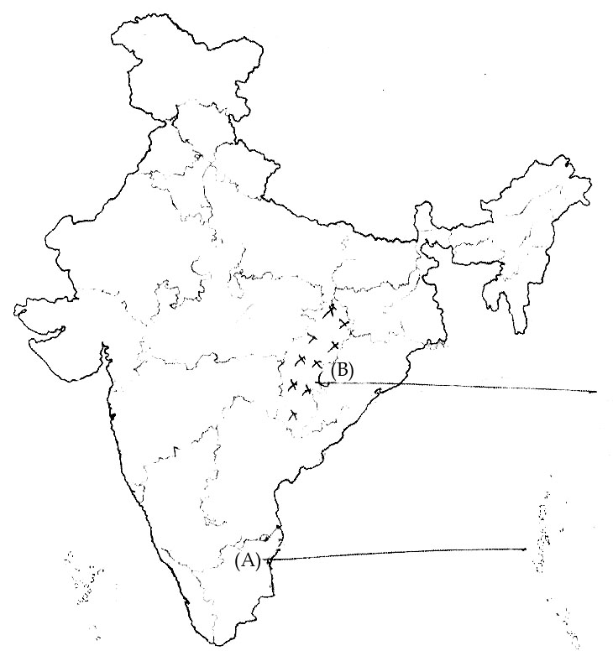  (C) Dehradun , where first Imperial Forest Research Institute was established. | 5
 | 28.  29.  30. |  | On the political outline map of India, locate and label the following items with appropriate symbols :  (A) Dachigam National Park.  (B) Tidal vegetation  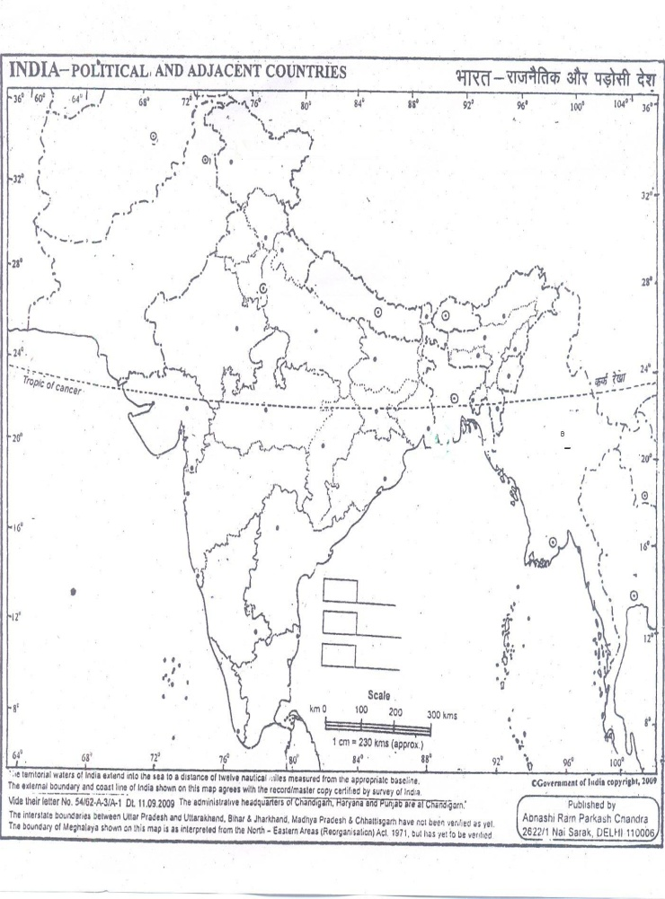  (C) The state having the highest sex ratio.  SECTION-B ( OTBA)  THEME-1  What are the dinsctive features of Indian monsoon?  What are the effects of monsoon on agriculture in India? | 3  5  5

