CLASS-IX
SUBJECT—SCIENCE
TERM—II
Time Allowed 3 Hours Max. Marks ; 90
General Instructions
- The question paper comprises two Three sections, A ,B and C. You are to attempt all the sections.
- All questions are compulsory.
There is no overall choice. However internal choice has been provided in all
the three questions of five marks category. Only one option in each question
is to be attempted,
- All questions of Section A and all questions of Section B and Section C are to be attempted separately.
- Question numbers 1 to 3 A are one mark questions.
- Question numbers 4 to 6 are two marks questions, to be answered in about 30 words each.
- Question numbers 6 to 16 are three marks questions, to be answered in about 50 words each.
- Question numbers 17 to 21 are five marks questions, to be answered in about 70 words each.
- Section B has 3 OTBA questions.Question number 22 is two marks,Question number 23 is of three marks and question number 25 is of five marks.
- Question number 25 to 33 in Section C are MCQ’S of 1 mark each.
- Question number 34 to 36 in section C of 2 marks based on practical
Skills.

- Question numbers 25 to 36 in Section B are practical based questions.
- Question numbers 25 to 33 are of one mark and 34 to 36 are of two marks each.

SECTION—A
- Write the chemical formula for Hydrogen sulphide and calcium carbonate?
- Define Species?
- Write the full form of HIV?
- What do you mean by formula unit mass ? Calculate the formula unit mass of C₆H₁₂O₁₁ and CuSO₄. 5H₂0.
- Write the main points of Rutherford's model of atom.
- Explain AIDS. List three symptoms of AIDS.
- Explain the formation of Acid Rain?
- How does atmosphere act as blanket?
- Differentiate acute and chronic diseases?
- What are specific ways of prevention of infectious diseases?
- Differentiate flying lizard and birds.
- Enlist the features of arthropods.
- Write the features of division Porifera.
- What is potential energy? Determine the potential energy when the object is at some height.

- A submarine emits a sonar pulse, which returns from under water cliff in 1.02 s. If the speed of sound in salt water is 1,531 m s ⁻¹, how far away is the cliff?
- How are power and work related?
- (a) Calculate number of atoms in 52 g of He and 52 moles of He.
(b) Give the name of the elements present
(a) Quick lime (b) Hydrogen bromide
(c) Baking powder (d) Potassium sulphate
- (a) Give the main points of the Bohr model of atom.
(b) What are its drawbacks?
- What is global warming? What are green house gases? List a few effects of global warming.
- A SONAR installed on a submarine sends out signal and receive an echo 5 s later. Calculate the speed of sound in water if the distance of object from submarine is 3,625 m.
- What is normal range of hearing? Give structure of ear to explain as to how sound is conveyed to brain?
SECTION-B
22. Waste management can help in improving the health status of our country. justify the statement
- Rag pickers act as saviors for municipal corporations. Elaborate on their role in waste
management.
- Suggest any one strategy for effective waste management being used in your area /locality/school.

SECTION-C
- Sound waves cannot travel in:
- Air b. Vacuum c. water d. metal
- Chloroplast present in spirogyra are :
- Book shaped
- b. irregular in shape
- c. ribbon shape
- d. spiral shaped
- Which one of the following is not the potential breeding ground for mosquitoes?
- Ponds b. lakes c. ditches d. river
- Relative density of a liquid is 0.8 its density in SI units is :
(A) 0.8 kg m⁻³ (B) 800 kg m⁻³
(C) 0.8 x 10⁴ kg m (D) None of three.
- Relative density is measured in :
(A) Nm⁻² (B) kg m⁻³
(C) g cm (D) None
- Sound can travel in :
- solids only
- liquids only
- gases only
- solids, liquids as well in gases.
- For reflection of sound, we need
- A highly polished mirror
- A concave mirror painted blue
- A large size opaque reflecting surface

- A glass plate.

- Faces of cuboid are marked 1 to 6 and depression on sand caused by each face is recorded. Record showed that :
- opposite parallel faces of cuboid caused the same depression in sand
- adjacent faces caused equal depression in sand
- all faces caused the same depression
- opposite parallel faces caused unequal depressions.

- . The adjacent diagram illustrates a specimen of Agaricus its parts have been labelled as P, Q, R, S.Write the correct matching of the parts with their function.
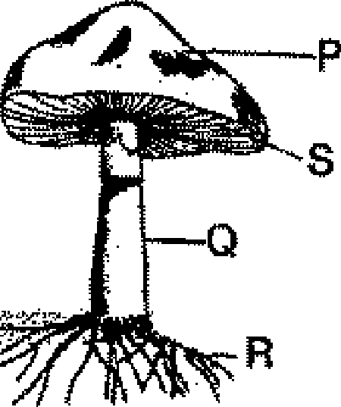

34.) List any two identifying features of class fungi.
35) Gizzard is a special organ in the digestive system of bird. What is its function?
36) The egg stage of mosquito lasts for how many days?

