SCIENCE IX
TERM-II (SA2)
TIME:-3 hours Max.Marks-90
GENERAL INSTRUCTIONS:-
- The question paper comprises of three sections A, B and C You are to attempt all the sections.
- All questions are compulsory.
- All sections of Section-A, Section-B and Section-C are to be attempted separately.
- Question numbers 1 to 3 in Section –A are one mark questions.These are to be answered in one word or in one sentence.
- Question number 4 to 5 in Section-A are two marks questions.These are to be answered in about 30 words each.
- Question numbers 6 to 16 in Section-A are three marks questions .These are to be answered in about 50 words each.
- Question numbers 17 to 21 in Section-A are five marks questions .These are to be answered in about 70 words each
- Section B has 3 OTBA questions. Question number 22 is two marks,Question number 23 is three marks and Question number 24 is five marks question.
- Question numbers 25 to 33 in Section-C are three multiple choice questions based on practicle skills.Each question is a one mark question. You are to select one most appropriate response out of the four provided to you.
- Question numbers 34 to 36 in Section-C are two marks questions based on practical skills .These are to be answered in about 30 words each.

SECTION-A

- Which form of energy will a body possess placed at the top of hill?
- Name two natural resources available on the earth?
- If Z=3,What would be the valency of element? Write the name of element.
- Calculate the mass of 1 molecule of Nitrogen gas.
- Prawn,housefly and spider belong to one group?
(i) Name the group. (ii) Justify the name given to this group.
- State two causes and two effects of depletion of ozone layer.
- Relative density of silver is 10.8 ,The density of water is 10³ kg/m³. What is density of silver in S.I. Unit?
- Give reasons-
a. Which divison among plants have the simplest organisms?
b. How do Gymnosperms and Angiosperms differ from each other?
- a. Why a person suffering once from small pox cannot suffer from it again?
b. Why prevention is better than cure?
- A child hears an echo from a cliff in 10 sec after the sound from an animal is produced. Calculate the distance between the cliff and the child. ( take velocity of sound as 340 m/s)
- a. Write the full form of SONAR.
b. Write two applications of SONAR.
- a. Define vaccine.
b.What type of diseases can be prevented through vaccination?
- a. Write 2 differences between acute and chronic diseases.
b.Give example of Infectious diseases. .
- Identify the phylum of the following 2 organisms and write 2 characteristic feature of each-

(a) (b)
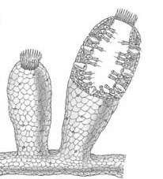
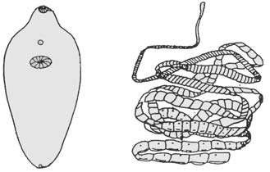

- Write the rules followed for filling the electrons in various energy shells of any atom,as proposed by bohr?
- a. Calculate the molar mass of CH3COOH. ( Atomic mass of C= 12 u, H=1 u,
O=16 u )
b. Write molecular formula for:- (i) Ammonium sulphate (ii) Sodium
carbonate
- a. Define Power.
b. A body of mass 45 Kg climbs up 20 steps in 20 sec if each step is 25 cm high,
calculate the power used in climbing. Take g = 10m/s2.
- Identify the energy transformation in the following- Hydroelectric power, explosion of cracker, And oscillating pendulum.
- a. What are polyatomic ions.Give examples?
b.Write atomicity of the following:-Sulphur and phosphorus
- Explain an activity with labeled diagram that sound needs material medium for propagation.
OR
Explain working of human ear with the help of well labelled diagram.

- Draw nitrogen cycle. OR Carbon cycle?

SECTION -B
- List the impact of consuming fish with high mercury levels on human health?
- List any three priority problem areas,based on the evidence of the linkages between poor environmental quality and health?
- Discuss the impact of chemicals on human health through a case-study other than those mentioned in the text?

SECTION-C
Multiple choice questions ( 1 MARK EACH)

- Jointed appandages are characteristic feature of :
a. Cockroach
b. Earthworm c. Bonyfish
d. Pigeon

- level of water in measuring cylinder before and after immersing a solid of mass 1.5 g has risen from point A to B as shown below. The density of the solid object would be:
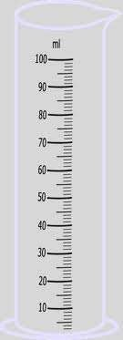

a. 1g/ cc b. 1.5 g/cc c. 2g/cc d. 0.75g/cc

- If the reflected and incident sound are at an angle of 90 degrees with each other, the incident angle should be:
a. 60 degrees b. 30 degrees c. 45 degrees d. 180 degrees

- 2 specimens A and B were observed by a child for spotting as shown below. After identifying the given specimens, in which of the following groups should he place them:
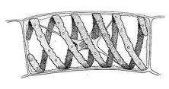
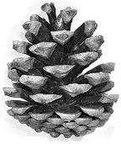

FIGURE - A FIGURE – B

s.no | A | B
A | Bryophyta | Pteridophyta
B | Pteridophyta | Gymnosperms
C | Algae | Gymnosperms
D | Gymnosperms | Algae

- A spring balance is used to calculate the mass of the body as shown below. A student calculated the least count of the spring balance and found it to be:
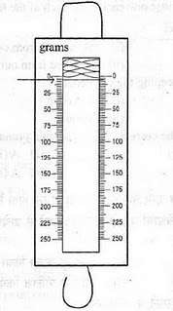

a. 1.5 gwt/division b. 2 gwt/division c. 2.5 gwt/division d. 1 gwt/division

- For doing experiment on verification of laws of reflection of sound successfully, the reflecting surface should be
a. A foam padded board.
b. A sheet of pure white cloth
c. A wooden board with many holes in it
d. A wooden board without holes

- The speed of sound in air is about
a. 3 x 108 m/s b. 340 m/s c. 340 cm/s d. 340 km/s

- Ribbon shaped and spiral chloroplast is present in which of the following organism:
a. Ulothrix b. Agaricus c. pirogyra
d. Chlamydomonas

- Seeds are naked in:
a. Angiosperms b. Gymnosperms c. Both of these d none of these

- A student observed that a block of mass 100g displaced 50 ml of water when dipped in measuring cylinder.calculate the density of the block?
- In a spring balance the space between 0 to 25 g wt is divided into 5 equal parts.Find its least count.
- Which feature of the body design helps a fish to swim in water?

