Holidays Homework
Class IX
Activities
1. Prepare a square root spiral for $√$7.
2. Verify the formula for (a +b +c)² by paper cutting and pasting.
3. Plot a graph of the numbers obtained on the top of the faces of two different coloured dice thrown 5 times.
Project
4. Prepare an A-4 sheet each on the following:
- History of Zero.
- Achievement of a Mathematician.
- Poem on Math.
- Proof of Pythagoras theorem.
5. Do the assignment of following questions attached alongwith.
Note: Learn multiple tables upto 20.

Assignment
1. If x = 1+ $√$2 , find the value of (x+$\frac{1}{x}$)³
2. Find the value of $\frac{7+√ 5}{7-√5}$ - $\frac{7-√5}{7+√5}$ = a + $\frac{7}{11} √5$ b.
3. Simplify $\frac{7√ 3}{√10+√3}-$ $\frac{3√ 2}{15+3√ 2}-$ $\frac{2√ 5}{√6+√5 }$
4. If a = $\frac{√2+1}{√2-1}$ and b = $\frac{√2-1}{√2+1},$ then find the value of a²+b²- 4ab.
5. What is the value of $\frac{√162+√108}{√72+√48}$
6. Find the values of a and b : $\frac{5+2 √3}{7+4 √3}$ = a – b$√$3
7. Evaluate $\frac{1}{√2+1}+\frac{1}{√3+√2}$ +$\frac{1}{√4+√3}$…………..$\frac{1}{√9+√8}$
8. Using factor theorem, show that (x-y) is the factor of x(y²-z²)+y(z²-x²)+z(x²-y²).
9. If both (x-2) and (x--$\frac{1}{2}$) are the factors of px²+5x+r then show that p = r.
10. If the polynomials az³+4z²+3z-4 and z³-4z+a leaves the same remainder when divided by (z-3) then find a.
11. For what value of m is x³-2mx²+16 divisible by (x+2)?
12. Find the values of a and b so that (z+1) and (z-1) are the factors of z⁴+az³+2z²-3z+b.
13. Draw the graph of the linear equation 3x+4y=6. At what points do the graph intersects the coordinate axes?
14. If the point (2k-3, k+2) lies on the graph of the equation 2x+3y+15 = 0, then find the value of k.
15. The ratio of girls and boys in a class is 1: 3. Set an equation between the students of the class and boys. Draw the graph also. Also find the no. of boys in a class of 40 students from the graph.
16. Half the perimeter of a rectangular garden is 36m. Write a linear equation which satisfies this data. Draw the graph for the same.
17. A point lies on x-axis at a distance of 5 units from y-axis on the right of the origin. Write the coordinates of the point.
18. In the given figure1 PQR is an equilateral triangle with coordinates Q and R as (-2, 0) and (2, 0) respectively. Find the coordinates of P.
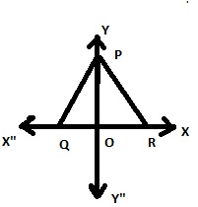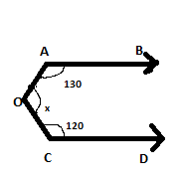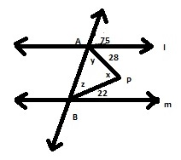
Fig 1 fig 2 fig 3

19. In figure2 AB$∥$CD. Find the value of x.
20. Given that l$∥$m and n intersects them at A and B respectively. AP and BP bisects the interior angles on same side of l and m, find /APB.
21. In $∆$ABC, the bisectors of /B and /C intersect at O inside the triangle, then prove that /BOC = 90 + $\frac{1}{2}$ /A.
22. Prove that the sum of three angles of a triangle is 180⁰.
23. PQRS is a square and $∆$SRT is an equilateral triangle, then prove that
- PT = QT b) /TQR = 15⁰
24. Prove that the vertically opposite angles of two intersecting lines are equal.
25. In the figure3 , AB $∥$ CD, find the values of x,y,z

