SUMMER HOLIDAY’S HOME WORK (2018-19)
CLASS-IST
SUBJECT-ENGLISH
1 Paste the words of ee, 'll and sh sound on A3 sheet. You can collect the words from the newspaper or magazine (only bold and big words) cut them out and paste it on your sheet.
2. Paste the pictures of any 4 cartoons and write their names. (A3 sheet)
e.g.
3. Paste the picture of your favourite toy and write 4 to 5 sentences. (A3 Sheet)
e.g . I have a toy car.
It has four wheels.

4.Do one page writing daily in a separate note book.
5. Read any 2-3 stories from any story book and learn the moral of the stories.
SUBJECT-HINDI
1.गरमी के मौसम में खाए जाने वाले फल और सब्जियों के चित्र अलग - अलग A3 size sheet पर चिपका कर उनके नाम लिखो! (5-5)
e.g. 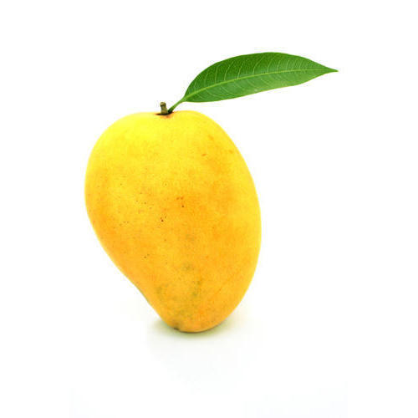 vke
2.आ से ऊ तक की मात्रा के पाँच -पाँच शब्द चित्र सहित A3 size sheet पर लिखो!
3.पाँच -पाँच श्रुतलेख (आ, इ तथा ई) मात्र की लिखो!
4. शब्द अंताक्षरी - शब्दों की रेलगाड़ी बनाएँ! (कोई पाँच शब्द)

e.g.
Fkjel
?kj
jFk

5. भाषा माधुरी पुस्तक के पाठ 1 से 7 पढ़ो!
SUBJECT-MATHS
1.Learn and write Number names 1 to 20 on A3 sheet.
e.g. 1 One
2 Two

2. Make 3 pictures on A3 sheet Using different geometrical shapes. You can paste cut -outs of shapes using glazed or fluorescent paper or paper from old magazines.
e.g. 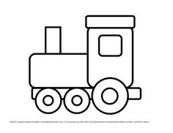Engine
3.Make a Calendar of your birthday month on A3 sheet and highlight your birthdate.
4.Make a creative wall hanging of tables 2 to 5.
e.g.
Table-2
2x1=2

2x2=4

2x3=6

SUBJECT-E.V.S
1.Prepare a wind chain showing the picture of food items that are healthy.
e.g.
HEALTHY FOOD ITEMS

VEGETABLES
PULSES
FRUITS

MILK

2.Grow a plant in any earthen pot. Water it daily, watch it daily and take care of it. Bring that pot school after vacation.
3.Make a hygiene kit.
Take a shoe box cover it with white chart paper properly and write hygiene kit on the lop of the box. Keep the following things in it.
1.hand sanitizer 2.paper soap
3.small comb 4.clean handkerchief
5.A small bottle of oil 6.A soap
4.Read a chapter daily of E.V.S book underline difficult words and consult your parents for the same.

SUBJECT-ART
Make a beautiful Photo Frame with Ice-cream sticks and decorate it beautifully with spare buttons and other material.
